3.
Configuring Extended ACLs
a.
Configure, Apply and Verify an Extended Numbered ACL

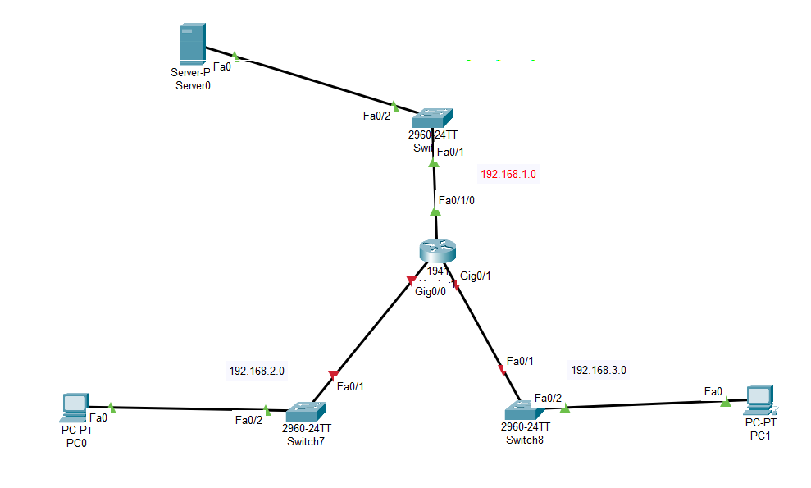

1️⃣ Addressing Plan
Network | Device | IP
Server LAN | Server0 | 192.168.1.10
Router G0/0 | 192.168.1.1
PC0 LAN | PC0 | 192.168.2.10
Router G0/1 | 192.168.2.1
PC1 LAN | PC1 | 192.168.3.10
Router G0/2 | 192.168.3.1
Subnet mask for all:
255.255.255.0

2️⃣ Router Configuration
Enter router CLI.
enable
configure terminal
hostname R1

Configure Interfaces

Server Network
interface g0/0
ip address 192.168.1.1 255.255.255.0
no shutdown
exit

PC0 Network
interface g0/1
ip address 192.168.2.1 255.255.255.0
no shutdown
exit

PC1 Network
interface g0/2
ip address 192.168.3.1 255.255.255.0
no shutdown
exit

3️⃣ PC and Server Configuration

PC0
IP: 192.168.2.10
Mask: 255.255.255.0
Gateway: 192.168.2.1

PC1
IP: 192.168.3.10
Mask: 255.255.255.0
Gateway: 192.168.3.1

Server
IP: 192.168.1.10
Mask: 255.255.255.0
Gateway: 192.168.1.1

4️⃣ Configure Extended ACL
Example requirement (common in labs):
👉 Block PC0 (192.168.2.10) from accessing Server (192.168.1.10)
👉 Allow all other traffic.
Create Extended ACL 100
access-list 100 deny ip host 192.168.2.10 host 192.168.1.10
access-list 100 permit ip any any

5️⃣ Apply ACL to Interface
Apply ACL closest to source network (PC0 network)
interface g0/1
ip access-group 100 in
exit

6️⃣ Save Configuration
end
write memory

7️⃣ Verify ACL
Check ACL list
show access-lists
Example output:
Extended IP access list 100
deny ip host 192.168.2.10 host 192.168.1.10
permit ip any any
Check interface ACL
show ip interface g0/1
You should see:
Inbound access list is 100

8️⃣ Test Connectivity

From PC0
ping 192.168.1.10
Result:
Request timed out
🚫 Blocked by ACL

From PC1
ping 192.168.1.10
Result:
Reply from 192.168.1.10
✅ Allowed

9️⃣ Test Router Connectivity
show access-lists
Hit counter example:
deny ip host 192.168.2.10 host 192.168.1.10 (5 matches)

Layer 2 VLAN Security

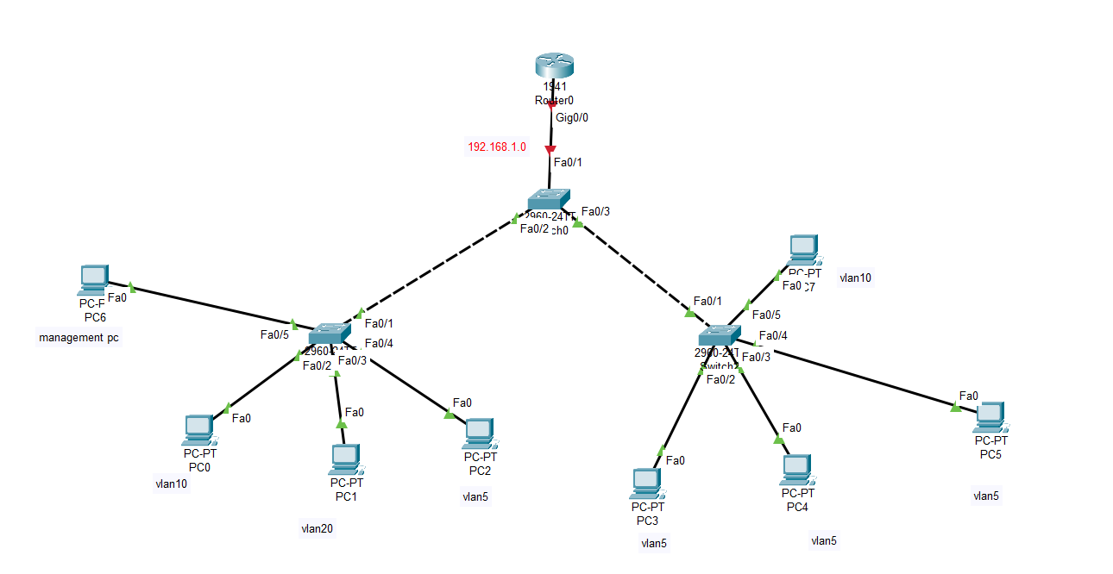

1️⃣ VLAN Plan
VLAN | Name | Devices
VLAN 10 | SALES | PC0, PC7
VLAN 20 | HR | PC1
VLAN 5 | IT | PC2, PC3, PC4, PC5
VLAN 99 | MANAGEMENT | PC6
Network example:
VLAN | Network
VLAN10 | 192.168.10.0/24
VLAN20 | 192.168.20.0/24
VLAN5 | 192.168.5.0/24
VLAN99 | 192.168.99.0/24

2️⃣ Core Switch (Middle Switch)
enable
configure terminal
hostname CoreSwitch

Create VLANs
vlan 10
name SALES
exit
vlan 20
name HR
exit
vlan 5
name IT
exit
vlan 99
name MANAGEMENT
exit

Configure Trunk Ports
Ports connecting to other switches:
interface fa0/2
switchport mode trunk
switchport trunk allowed vlan 5,10,20,99
exit
interface fa0/3
switchport mode trunk
switchport trunk allowed vlan 5,10,20,99
exit

Router Connection
interface fa0/1
switchport mode trunk
exit

Security (Disable unused ports)
interface range fa0/4-24
shutdown
exit

3️⃣ Left Access Switch
enable
configure terminal
hostname Switch1

VLAN Creation
vlan 10
vlan 20
vlan 5
vlan 99

Access Ports
PC0 → VLAN10
interface fa0/5
switchport mode access
switchport access vlan 10
switchport port-security
switchport port-security maximum 1
switchport port-security violation shutdown
switchport port-security mac-address sticky
exit
PC1 → VLAN20
interface fa0/2
switchport mode access
switchport access vlan 20
switchport port-security
switchport port-security mac-address sticky
exit
PC2 → VLAN5
interface fa0/3
switchport mode access
switchport access vlan 5
switchport port-security
switchport port-security mac-address sticky
exit
Management PC → VLAN99
interface fa0/1
switchport mode access
switchport access vlan 99
exit

Trunk to Core
interface fa0/4
switchport mode trunk
switchport trunk allowed vlan 5,10,20,99
exit

4️⃣ Right Access Switch
enable
configure terminal
hostname Switch2

VLAN Creation
vlan 10
vlan 5
vlan 99

Access Ports
PC3
interface fa0/2
switchport mode access
switchport access vlan 5
switchport port-security
switchport port-security mac-address sticky
exit
PC4
interface fa0/3
switchport mode access
switchport access vlan 5
switchport port-security
switchport port-security mac-address sticky
exit
PC5
interface fa0/4
switchport mode access
switchport access vlan 5
switchport port-security
switchport port-security mac-address sticky
exit
PC7 → VLAN10
interface fa0/5
switchport mode access
switchport access vlan 10
switchport port-security
switchport port-security mac-address sticky
exit

Trunk to Core
interface fa0/1
switchport mode trunk
switchport trunk allowed vlan 5,10,20,99
exit

5️⃣ Router Configuration (Router-on-a-Stick)
enable
configure terminal
hostname Router0

Enable interface
interface g0/0
no shutdown

VLAN 10
interface g0/0.10
encapsulation dot1Q 10
ip address 192.168.10.1 255.255.255.0
exit

VLAN 20
interface g0/0.20
encapsulation dot1Q 20
ip address 192.168.20.1 255.255.255.0
exit

VLAN 5
interface g0/0.5
encapsulation dot1Q 5
ip address 192.168.5.1 255.255.255.0
exit

Management VLAN
interface g0/0.99
encapsulation dot1Q 99
ip address 192.168.99.1 255.255.255.0
exit

6️⃣ PC IP Configuration
PC | VLAN | IP | Gateway
PC0 | 10 | 192.168.10.10 | 192.168.10.1
PC1 | 20 | 192.168.20.10 | 192.168.20.1
PC2 | 5 | 192.168.5.10 | 192.168.5.1
PC3 | 5 | 192.168.5.11 | 192.168.5.1
PC4 | 5 | 192.168.5.12 | 192.168.5.1
PC5 | 5 | 192.168.5.13 | 192.168.5.1
PC7 | 10 | 192.168.10.11 | 192.168.10.1
PC6 | 99 | 192.168.99.10 | 192.168.99.1

7️⃣ Verification Commands

Check VLAN
show vlan brief

Check trunk
show interfaces trunk

Check port security
show port-security

Check router VLAN interfaces
show ip interface brief

